Practical no. 2
Name :- Danish Altaf Solkar Enrolment no. :-24111590805
Class :- CO3K – B Subject :- DMS
Aim:- Create Database Schema for given Application

QUERY :- CREATE TABLE coa(Rollno NUMBER(10),Name VARCHAR2(50),Sal NUMBER(6,2));

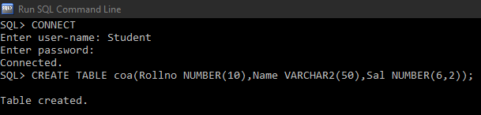

QUERY :- CREATE TABLE Empl(Empno NUMBER(10)Primary key,Ename VARCHAR(50),Sal NUMBER(6,2));

QUERY :- ALTER TABLE Empl ADD mgr NUMBER(20);

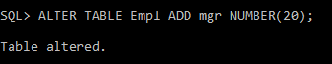

QUERY :- ALTER TABLE Empl DROP COLUMN mgr;

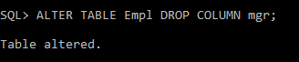

Exercise :-
1) How would you create a new database named EMP?
ANS. CREATE USER emp IDENTIFIED BY emp123;
GRANT CONNECT, RESOURCE TO emp;
2) Write the SQL commands to create the EMP table with the following structure:
• empno as a number datatype with up to 4 digits
• ename as a variable character datatype up to 10 characters
• job as a variable character up to 9 characters
• mgr as a number datatype with up to 4 digits
• hiredate as a date
• sal as a number with up to 7 digits, including 2 decimal places
• comm as a number with up to 7 digits, including 2 decimal places
• deptno as a number with up to 2 digits
ANS. CREATE TABLE EMP (
empno NUMBER(4),
ename VARCHAR2(10),
job VARCHAR2(9),
mgr NUMBER(4),
hiredate DATE,
sal NUMBER(7,2),
comm NUMBER(7,2),
deptno NUMBER(2)
);
3) How would you alter the EMP table to assign the empno column as the primary key?
ANS. ALTER TABLE EMP
ADD CONSTRAINT pk_emp PRIMARY KEY (empno);
4) Write the SQL commands to create the DEPT table with the following structure:
• deptno as a number with up to 2 digits
• dname as a variable character datatype up to 10 characters
• loc as a variable character up to 20 characters
ANS. CREATE TABLE DEPT (
deptno NUMBER(2),
dname VARCHAR2(10),
loc VARCHAR2(20) );

